Preparatory Problems for

the 58th International Chemistry Olympiad 2026

Tashkent, Uzbekistan

Practical Problems

Contents
Fields of advanced difficulty 111
List of GHS hazard statements and H codes 112
Introduction to microplates (96-well plates) and micropipettes 113
Introduction to vacuum filtration technique 117
Introduction to titration using a pH meter 118
Problem 31. Blue pigment 120
Problem 32. Synthesis and characterisation of metal complexes with a hydrazone-based ligand 126
Problem 33. Titration of apple juice 129
Problem 34. Cottonseed oil 133
Problem 35. An unknown salt 138
Problem 36. Khodja Nasreddin’s secret message 144

Fields of advanced difficulty
Practical
- Using micropipettes and 96-well plates.
- Vacuum filtration.
- Titration using pH meter.

The students are not expected to be specifically trained on the hereunder topics:
- Recrystallisation.
- Using spectrophotometer.

List of GHS hazard statements and H codes
H221 | Flammable gas
H225 | Highly flammable liquid and vapour
H226 | Flammable liquid and vapour
H272 | May intensify fire; oxidiser
H290 | May be corrosive to metals
H301 | Toxic if swallowed
H302 | Harmful if swallowed
H312 | Harmful in contact with skin
H314 | Causes severe skin burns and eye damage
H315 | Causes skin irritation
H317 | May cause an allergic skin reaction
H318 | Causes serious eye damage
H319 | Causes serious eye irritation
H331 | Toxic if inhaled
H332 | Harmful if inhaled
H334 | May cause allergy or asthma symptoms or breathing difficulties if inhaled
H335 | May cause respiratory irritation
H341 | Suspected of causing genetic defects
H351 | Suspected of causing cancer
H372 | Causes damage to organs through prolonged or repeated exposure
H373 | May cause damage to organs through prolonged or repeated exposure
H400 | Very toxic to aquatic life
H410 | Very toxic to aquatic life with long-lasting effects
H411 | Toxic to aquatic life with long-lasting effects
H412 | Harmful to aquatic life with long-lasting effects

Please note that the table of Globally Harmonised System (GHS) hazard codes provided for the chemicals used in these experiments is intended as a reference only. There is no guarantee that the information provided is perfect or complete. The list does not replace the need for professional attention to local regulations and the safety information provided by the actual suppliers of the chemicals.

Introduction to microplates (96-well plates) and micropipettes
Part A: What is a microplate?
This summer, you will visit the ancient city of Samarkand, a central part of the world's scientific heritage. Next to the Bibi-Khanym Mosque, you will notice the laughter of customers, the selling buzz of the traders and the colour of the most authentic products in the world – the Siyob Bazaar.
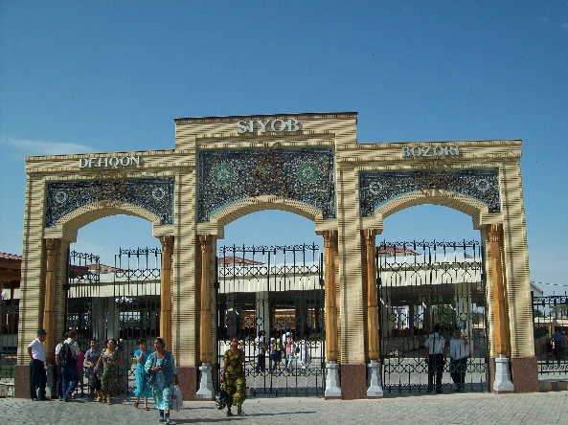 | 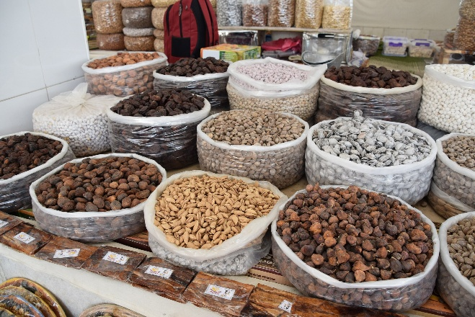
Figure 1. Entrance of the Siyob Bazaar and one of the delicious offerings hidden behind the gates. Maybe there are more? Images are reproduced from Wikipedia, under Wikimedia Commons, CC BY-SA 4.0.
In the Siyob Bazaar, your curiosity leads you to souvenirs, exotic food, and spices. So, you need a container of sufficient size for this. However, you don’t want to select a lot, just enough so you can carry it all back home. For this, you are given a rectangular plastic tray, the size of your hand, with 96 tiny boxes in a grid of 8 rows and 12 columns. That’s a 96-well plate – your access not only to the mystical culture of Uzbekistan, but to performing multiple, parallel microscale reactions for the practical problems in this set. There are, of course, trays with different box sizes, depending on how much candy you want to fill them with.
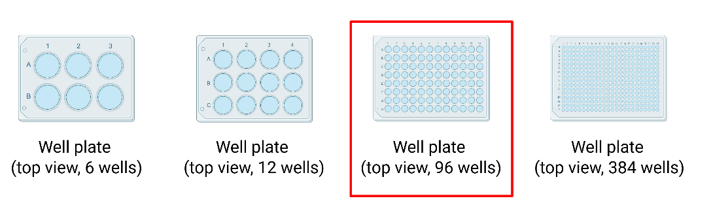
Figure 2. Types of multi-well plates. The 96-well plate is highlighted in red.
Each “box” is referred to as a “well”. It is nothing more than a small container that holds a micro-volume of up to 300 µL, depending on the vendor. A 96-well plate really is like a box of chocolates, just for chemical reactions. For practical purposes, we will use the terms “microplate” and “96-well plate” synonymously.

Why a microplate for microscale reactions?
Instead of running one reaction experimental condition at a time with such a small volume, we can run up to 96 experiments simultaneously. This is incredibly useful when we need to:
- Test multiple samples at the same time.
- Compare how different concentrations of reagents affect different reactions.
- Screen multiple reactions quickly.
- Save time, materials, and space in the laboratory.
Finding your way in a microplate
The microplate uses a simple coordinate system, like an Excel spreadsheet or the game of Battleships:
- The rows are labelled with letters A–H. There are 8 rows in total.
- The columns are numbered with numbers 1–12. There are 12 columns in total.
Every well has a unique identity. For example, the well in the top-left corner is A1, while the well in the bottom-right corner is H12. The well, three rows down and five columns across, would be C5. See Figure 3 for clarity. This naming system helps scientists keep track of exactly what's in each well and ensures experiments are organised and, hopefully, reproducible.
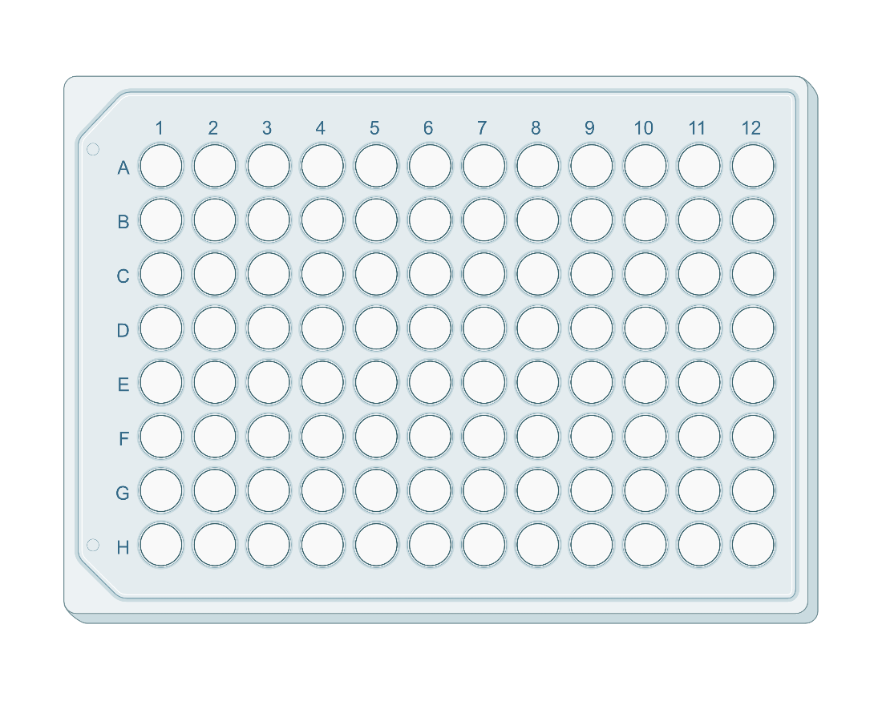

Figure 3. The classical organisation of a 96-well plate. The discussed wells in the text are marked with purple circles.
Basic terminology
- Well: the individual container or “box” in the plate.
- Micropipette: A special tool that transfers liquid into a single well.
How to operate a microplate?
- Sketch out your plate layout on paper or use a template. It is crucial to know exactly which chemical and which concentration goes in the corresponding well.
- Pay attention to the volumes used. Follow the instructions of the experimental procedures where this is denoted.
- Beware of cross-contamination. Be careful not to let your pipette tip touch the liquid of a well other than the one you are working with before moving to another well. On a microscale, this will contaminate your samples and ruin your experiment.
Part B: What is a micropipette?
The definition of the pipette (micropipette) is given above. Micropipettes are used to measure and transfer small amounts of liquids (from 1 μL and up to 5 mL). Note that there are different types of micropipettes, thus particular items has much narrower range. Be sure to check it before using.
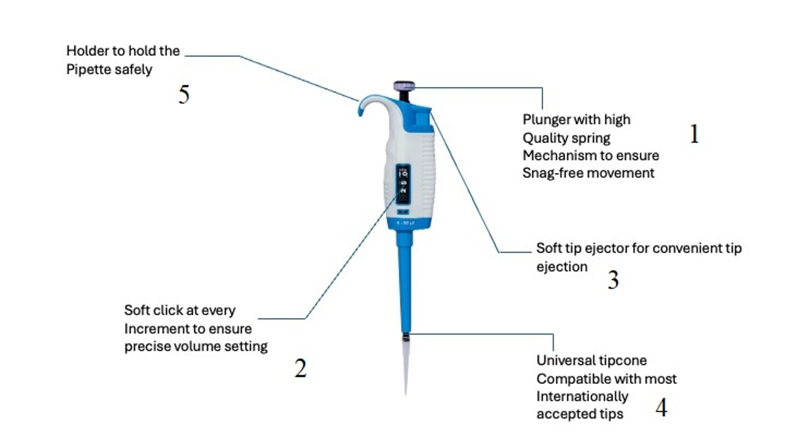
Micropipette operation
- Setting the delivery volume:
- Set the delivery volume using the push button on the top of the micropipette (1). To increase the delivery volume, turn the push button counter-clockwise. To decrease the delivery volume, turn it clockwise.
Note: Micropipettes from other manufacturers can have a different design of the ring used to adjust volume. If you have trouble finding or using it, approach your lab assistant.
- Make sure that the desired delivery volume clicks into place. Check the volume reading at window 2.
- Do not set a volume that lies outside the micropipette’s specified volume range. Using excessive force to turn the push button outside the range may jam the mechanism and eventually damage the micropipette.
- Tip ejection:
In order to eject the tip, point the micropipette at a suitable waste receptacle and press the ejector button (3) with your thumb.

- Doing pipetting:
- Press and release the push button (1) slowly. Do not let it snap.
- Make sure that the tip is firmly attached to the tip cone (4).
- Before you begin your actual work, fill and empty the tip 2–3 times with the reagent or solution that you will be pipetting.
- Hold the micropipette in an upright position while aspirating. The holder (5) must rest on your index finger.
- Fill a clean reagent/solution reservoir with the reagent/solution to be dispensed.
- Press the push button (1) till the first stop.
- Dip the tip under the upper surface of the reagent/solution in the reservoir, till a depth of about 1 cm.
- Slowly release the push button.
- Withdraw the tip from the reagent/solution.
- Let the tip touch against the edge of the reservoir to remove the excess reagent/solution.
- Deliver the reagent/solution by gently pressing the push button till the first stop. After a delay of about one second, stop. This action will empty the tip.
- Release the push button to let it retract to the ready position. If necessary, change the tip and continue pipetting. Always use a new clean tip when pipetting a new reagent/solution.
- Final instruction: follow the order of addition specified in the task, as it might be important to obtain the correct observations. Good luck!

Introduction to vacuum filtration technique
Part A: What is vacuum filtration?
Filtration is a physical process used to separate the solid from the liquid by passing the mixture through a filter. Vacuum filtration applies suction to pull the solution, the mixture or suspension through the filter. For the filter, one can use a paper filter with a regular funnel or Büchner funnel, cotton with a regular funnel or sintered glass funnel.
Part B: Typical vacuum filtration set-up
The apparatus for vacuum filtration consists of a filter flask (Büchner flask or round-bottom flask with an appropriate connector), a filter that is sealed with a rubber vacuum seal or glass joint, and a vacuum hose connected to a vacuum pump. It is always recommended to mount the filter flask firmly to a lab stand using a clamp.
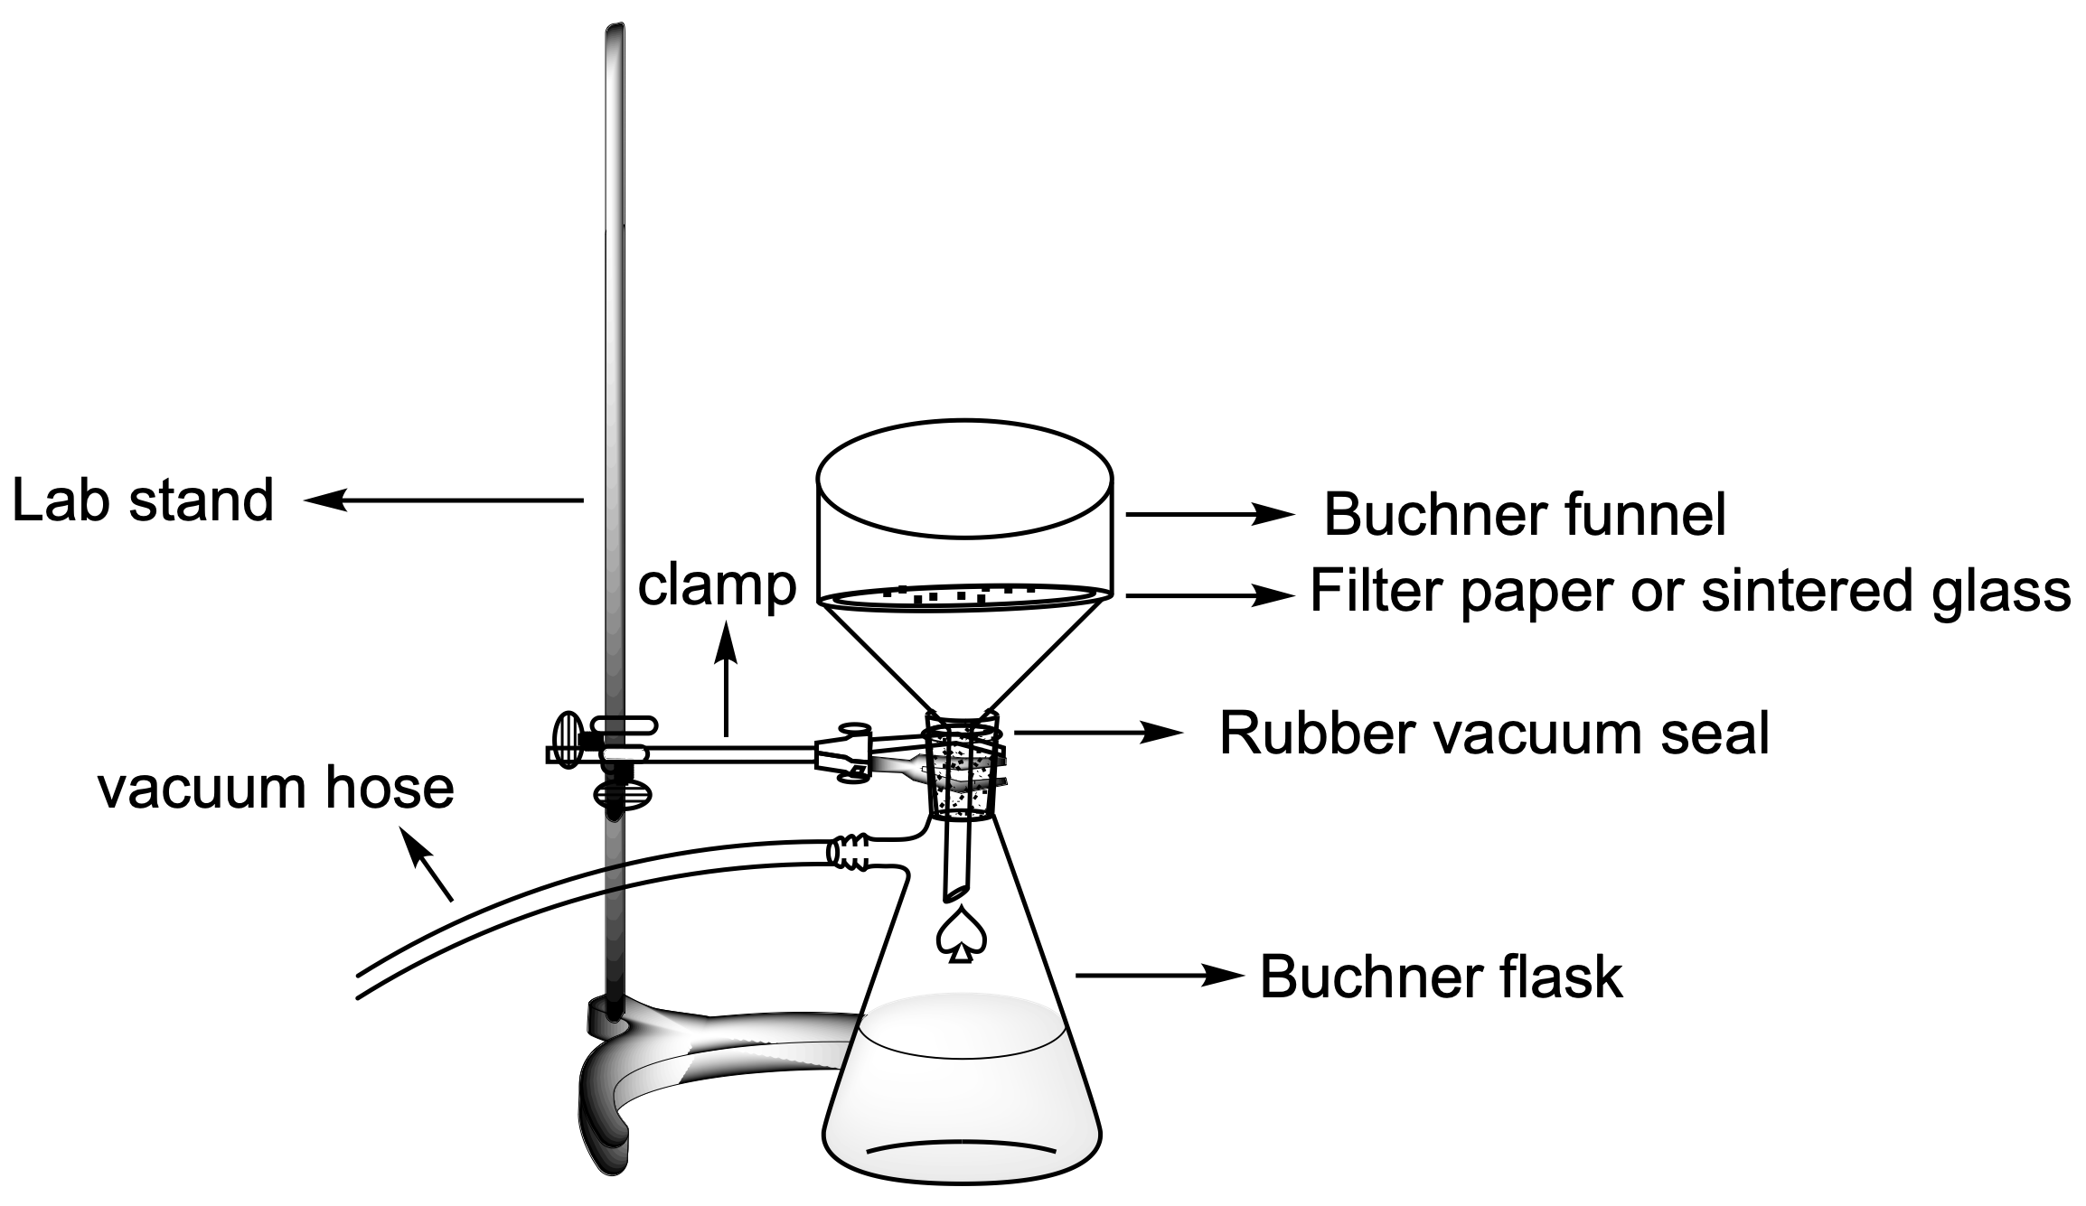 | 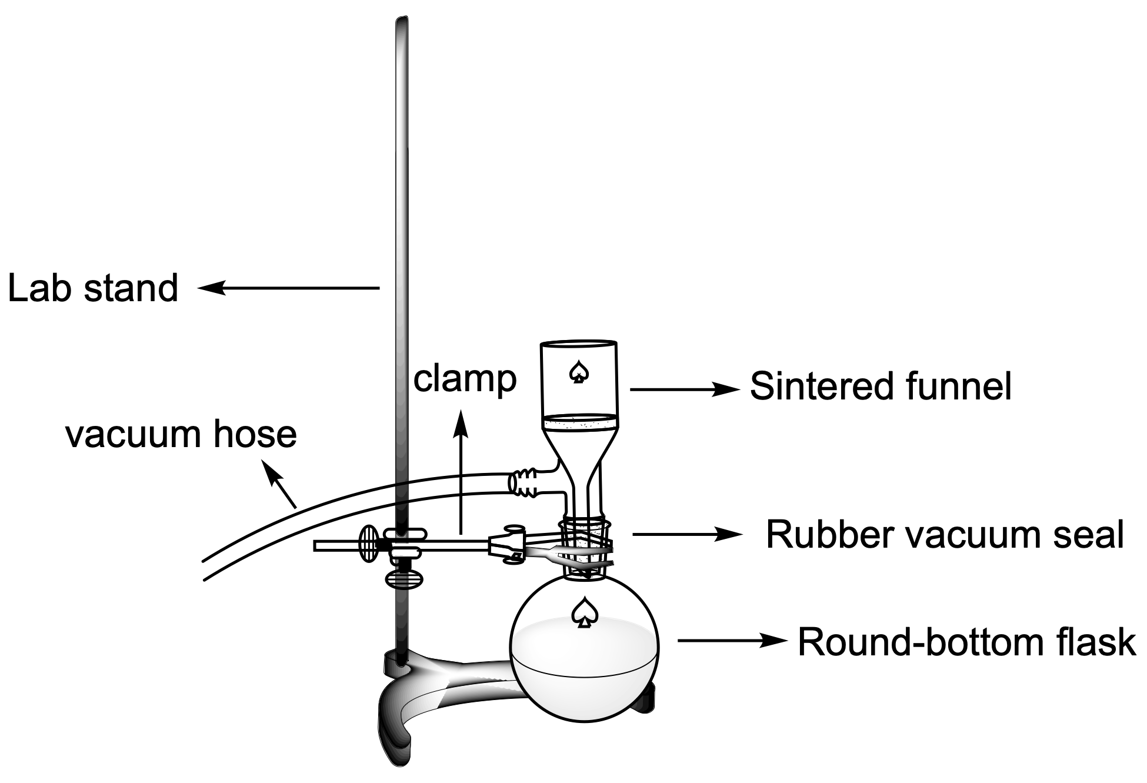
Part C: General instructions for vacuum filtration
- Clamp the filter flask to a lab stand using an appropriate clamp.
- Connect the filter using a rubber seal or a filter with the appropriate size of glass joint.
- Connect one end to the vacuum valve on your bench and another end of the vacuum hose to the apparatus through the suction inlet.
- Turn the vacuum on.
- Inspect the suction by gently placing the palm of your hand on the top of the filter or passing some of the solvent through the filter.
- Pour the mixture to be filtered from the reaction flask or beaker into the funnel using a glass rod, spatula or spout of the beaker if necessary. Fill a maximum of 3/4 of the funnel height and do not let it overflow.
- Once the solution is fully transferred and the liquid is drained completely, disconnect the vacuum hose carefully and/or turn off the vacuum.
- If it is necessary to wash the desired solid, rinse the reaction container, pour the washing liquid over the solid and mix thoroughly. Turn the vacuum back on to discard the washing liquid. Repeat the washing as many times as required.
- Turn the vacuum on and let the air pass through to dry the solid. When the compound is dry enough (usually 5–15 min), scrape out the solid and crush it for more effective drying in air or on the filter. Dry the solid for a period of 5 min to 1 h as necessary.
- Turn the vacuum off and remove the hose from the apparatus.
- Using a spatula, transfer the solid to another container if required by the instructions.

Introduction to titration using a pH meter
Part A: What is a pH meter?
A pH meter is a scientific instrument that measures the hydrogen-ion concentration in water-based solutions, indicating their acidity or alkalinity expressed as pH. The pH meter measures the difference in electrical potential between a pH electrode and a reference electrode, and so the pH meter is sometimes referred to as a “potentiometric pH meter”. The difference in electrical potential relates to the acidity or pH of the solution. Testing of pH via pH meters (pH-metry) is used in many applications, ranging from laboratory experimentation to quality control.
Potentiometric titration with a pH meter can be used to determine the concentration of an acid or a base. This is done by recording the pH change as a function of the titrant volume. Instead of relying on a colour-changing indicator, you use a pH meter with an electrode put into the titrated solution. As you add the titrant (for example, adding a base to an acid), at first, the pH changes gradually, but around the equivalence point, the pH increases or decreases sharply. If you plot the change in pH against the volume of the titrant, you’ll see a characteristic S-shaped curve. The steepest part of that curve marks the equivalence point.
Part B: Typical set-up for titration using a pH meter
It consists of a pH meter with its electrode, a fixed burette attached to the lab stand, a plastic beaker, a glass rod or a magnetic stirring bar. It is recommended that the electrode in the solution does not touch the wall and the bottom of the beaker, plastic beaker or magnetic stirring bar.
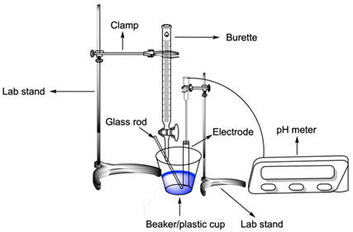 | 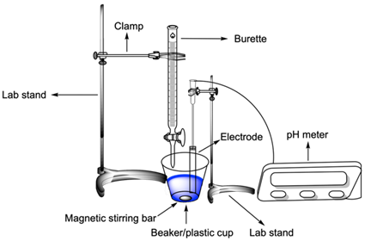
Part C: General instructions for titration using a pH meter
- Make sure that the pH meter is calibrated and ready for use.
- Set up the equipment as shown above.
- Keep the electrode of the pH meter inside the storage solution. Do not leave the electrode dry for too long when it is not in use. Either leave it in the sample solution between measurements or in the storage solution if not in use for a long period of time.
- Rinse the electrode with deionised water and dry it with tissue.
- Immerse the pH meter electrode in the titrating solution, which contains a glass rod or magnetic stirring bar.
- After each titrant probe addition, stir with a glass rod for 5 seconds (or use a magnetic stir bar), then measure the pH of the solution.
- Do not touch the electrode with the glass rod or stir bar, as this may damage the electrode.
- When you finish your titration, rinse the electrode with deionised water and dry it with tissue. Then, put the electrode back into the storage solution or use it in the next titration.

Problem 31. Blue pigment
Equipment
Item | Quantity
Part A
Beaker, 250 mL | 1
Stirring bar | 1
Measuring cylinder, 25 mL | 1
Hotplate with magnetic stirrer | 1
Small spatula | 1
Sintered funnel | 1
Filtration flask | 1
Vacuum pump | 1
Part B
Volumetric flask, 100 mL | 1
Laboratory stand with burette clamp | 1
Burette, 25 mL | 1
Volumetric pipette, 10 mL | 1
Conical flask, 100 mL | 2
Aluminium foil | 1
Pipette bulb | 1
Small funnel | 2
Small beaker under the burette | 1
Part C
96-well plate  (or transparent Eppendorf tubes) | 1  (or 30)
Pasteur pipettes | 6+2 extra pieces
Microspatula | 1
Black paper | 1 piece
White paper | 1 piece
Chemicals
Name | State | Concentration | Quantity | Placed in | Label
Part A
A | Solid | – | 1.87 g | Vial | A-synth
B | Solid | – | 9.00 g | Vial | B-synth
Distilled water | Liquid | – | 500 mL | Washing bottle | H₂O
Part B
Pigment X | Solid | – | ~1 g | Volumetric flask | Pigment X  m(X) = ... g
Sulfuric acid | Aqueous solution | 10% | 40 mL | Vial | H₂SO₄ (10%)
Potassium iodide | Aqueous solution | 1 M | 20 mL | Vial | KI (1 M)
Sodium thiosulfate | Aqueous solution | 0.1000 M | 50 mL | Bottle | Na₂S₂O₃  (0.1000 M)
Starch indicator | Aqueous solution | 1% | 1 mL | Eppendorf tube | Starch
Part C
A | Aqueous solution | 0.5 M | 0.5 mL | Vial | A
B | Aqueous solution | 0.5 M | 0.5 mL | Vial | B
C | Solid | – | 0.2 g | Vial | C
D | Aqueous solution | 0.5 M | 0.5 mL | Vial | D
E | Aqueous solution | 0.5 M | 0.5 mL | Vial | E
F | Aqueous solution | 0.5 M | 0.5 mL | Vial | F
GHS Codes
Chemical | GHS Code(s)
A | H302, H318, H410
B | no hazards
C | no hazards
D | H272, H314, H410
E | H302, H318
F | H319
X | H302, H319, H332, H410
Sulfuric acid (10%) | H290, H314, H335
Potassium iodide | H372
Sodium thiosulfate | no hazards
Starch indicator | no hazards



Uzbekistan is known worldwide for its architectural heritage and rich history. The cities of Samarkand, Bukhara, and Khiva are called the Pearls of the East for their ancient past and architectural masterpieces. Their madrasas, mosques, and mausoleums are renowned for intricate tilework and majestic blue domes that shimmer in the sunlight and have become one of the country’s most iconic symbols. Blue pigment X is one of the components used in creating the blue domes.
In this task, you will explore different synthetic routes towards blue pigment X and analyse it.
Part A: Synthesis of pigment X
- Place compound A (1.87 g) in a 250 mL beaker.
- Add 25 mL of H₂O and a magnetic stirring bar.
- Clamp the beaker on the stirring plate and start stirring. Wait until A is completely dissolved.
- While stirring, add compound B (9.00 g) in small portions to the solution of A. Before adding a new portion, wait until the effervescence has subsided. The approximate total time of addition is 15–25 min.
- After the addition is completed, stir the solution for 5 min.
- While stirring, add 25 mL of H₂O to the solution (wash the beaker wall) and stir for an additional 20 min.
- Turn off the stirring and check if the solution has become almost colourless. If not, continue stirring the solution until it becomes colourless.
- Add 30 mL of H₂O and stir the reaction mixture for 5 min.
- Perform the vacuum filtration of the mixture using the sintered funnel and wash the precipitate X on it with 10 mL of ice-cold H₂O.
- Dry the product on the sintered funnel for 30 min. You can perform the subsequent parts of the tasks while drying.
Q1. Weigh the product and record its mass.
Note: The product will be dried in air overnight and re-weighed by the lab staff.
Part B: Analysis of pigment X
You are provided with a sample of the pigment. In this part, we will analyse it and deduce its structural formula.
- Note the exact mass of sample X in the volumetric flask.
- Add 15 mL of 10% H₂SO₄ portion-wise to X in the volumetric flask while swirling.
Q2. Note your observations.
- After dissolving is complete, dilute the solution with distilled water to the mark.
- Transfer a 10.0 mL aliquot of this solution into a conical flask.
- Add 5 mL of 10% H₂SO₄ and 5 mL of 1 M KI.
- Cover the flask with aluminium foil and leave it for about 5 min in a dark place.
- Titrate the formed iodine with the standard 0.1000 M solution of Na₂S₂O₃ until the colour turns pale yellow. Then add 2–3 drops of the starch solution and continue titration until the blue colour disappears.
- Repeat steps 2–3 as necessary.
Q3. Record your results.
Q4. Write the reaction equations for steps 5 and 7.
Q5. Calculate the mass percentage of the heaviest atom in the sample of X.
Part C: The way to identify A, B and X
There are various procedures to synthesise this pigment. Besides compounds A and B, one can use three chemicals out of the four salts C–F. You will perform pairwise reactions with them to identify compounds A–F.
It is known that:
- The set A–F contains three different cations.
- Na⁺ is one of the cations.
- Two unknown metal cations are in the same period of the Periodic table.
- Each cation is present twice in the set A–F.
- The set A–F contains four different anions.
- NO₃⁻ is one of the anions.
- Two anions are present once, while the other two are present twice in the set A–F.
- Two anions are formed from the same acid.
Using the pairwise reaction method, identify the salts A–F. Perform the pairwise reactions as follows:
- Take the well plate or Eppendorf tubes.
- Add 2–3 drops or 1 microspatula of the first reagent to a well.
- Add 2–3 drops or 1 microspatula of the second reagent to the same well.
- Write down the observations, if any. In case of no reaction, write “NR”.
- Wait for approximately 5 min and note additional observations, if any.
Note: For your convenience, you can use black or white paper as a background to see the reaction results more clearly.
Q6. Write the observations from the performed pairwise reactions in the following table.
 | A | B | C | D | E | F
A
B
C
D
E
F
Different indicators can help to identify the metal ions in solution. One reagent that can be used is dithizone. The colours of metal complexes formed by several metals in aqueous solution with dithizone (in acetone) are shown below.
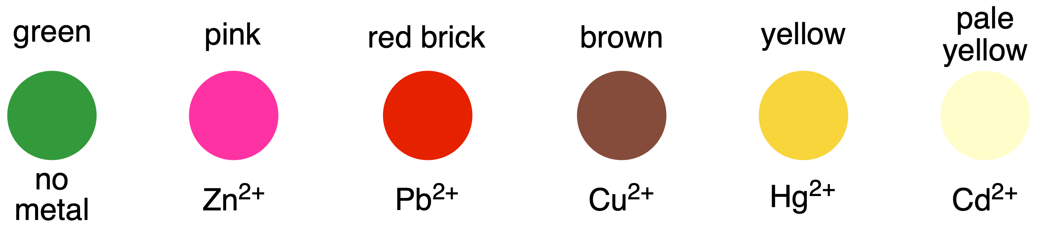
Q7. Assuming solution D gives a brown colour with dithizone, suggest the colour of solution A after reaction with dithizone.
Q8. Identify the formulae of compounds A–F based on your observations and provided information.
Q9. Suggest additional tests that can help you to identify the unknown compounds. You may use only the chemicals present in this task.
Q10. Choose the compound from A–F which cannot be used to obtain pigment X through pairwise reaction.
Q11. State whether solid C is soluble in H₂O.

Problem 32. Synthesis and characterisation of metal complexes with a hydrazone-based ligand
Equipment
Item | Quantity
Shared
Analytical balance | 1
For each student
Hotplate with magnetic stirrer | 1
Stirring bar | 1
Vacuum filtration set-up | 1
Beaker, 100 mL | 3
Beaker, 50 mL | 1
Spatula | 2
Pasteur pipette, 1.5 mL | 1
Vial, 30 mL | 2
Measuring cylinder, 50 mL | 1
Measuring cylinder, 10 mL | 2
Measuring cylinder, 1.5 mL | 1
Conical flask, 100 mL | 1
Ice-water bath | 1
Chemicals
Name | State | Conc. | Quantity | Placed in | Label
Deionised water | Liquid | – | 500 mL | Wash bottle,  500 mL | H₂O dist.
Ethanol | Liquid | – | 100 mL | Bottle,  500 mL | Ethanol
Benzhydrazide | Solid | – | 1.5 g | Vial | Benzhydrazide
Salicylaldehyde | Liquid | – | 2 mL | Vial | Salicylaldehyde
Copper (II) chloride dihydrate | Solid | – | 1 g | Vial | СuCl₂
GHS Codes
Chemical | GHS Code(s)
Deionised water | no hazards
Ethanol | H225
Benzhydrazide | H301, H315, H319, H335, H351
Salicylaldehyde | H302, H312, H315, H319, H341
Salicylaldehyde benzoyl hydrazone | no hazards
Copper(II) chloride dihydrate | no hazards
Hydrazones are a common class of condensation products that are widely studied in organic and coordination chemistry. In this problem, you will synthesise salicylaldehyde benzoyl hydrazone (SBH) and its metal complex.
Part A: Synthesis of SBH
Note: This part of this synthesis should be performed under the fume hood.
- Weigh 1.0 g benzhydrazide into a 100 mL beaker, place the beaker on the magnetic stirrer, put the stirring bar and dissolve the solid in 40 mL of distilled water while stirring.
- To the second 100 mL beaker, add 1.5 mL salicylaldehyde (ρ = 1.17 g·cm⁻³) using the Pasteur pipette, and dissolve in 15 mL ethanol. Use the same Pasteur pipette and add this solution dropwise to the benzhydrazide solution with stirring.
- Continue to stir the resulting mixture at a lower speed for 10 min.
- Filter off the product using vacuum filtration and wash the solid twice with 7 mL of ice-cold ethanol.
- Transfer the solid to the 100 mL beaker and put the stirring bar in it.
- Add 20 mL of ethanol and heat this solution on the hotplate with stirring until the solid completely dissolves.
- Remove the beaker from the hotplate and put it in the ice-water bath to complete the crystallisation.
- Collect your pure product using vacuum filtration, wash twice with 7 mL ice-cold ethanol.
- Dry the solid in air with the operating vacuum pump for 30 min.
- Weigh the vial and record the balance reading. Transfer the solid to the pre-weighed vial.
Q1. Write the reaction equation showing the structural formulae of the reagents and the product.
Q2. Calculate the reaction yield.
Part B: Synthesis of a copper complex
- Weigh 0.51 g of CuCl₂·2H₂O into the 50 mL beaker and dissolve it in 5 mL of ethanol.
- Weigh 0.72 g of the SBH you prepared in Part A into a 100 mL conical flask, add 10 mL of ethanol using the measuring cylinder and put the stirring bar in the flask.
Note: If you did not get the desired product in Part A or its quantity is less than required, use the SBH given by your lab assistant.
- Turn on the stirring.
- Heat this mixture on the hotplate to facilitate dissolution of SBH.
- When the SBH has completely dissolved, remove the conical flask from the hotplate, quickly add the metal salt solution and swirl to mix.
- Once precipitation begins, place your flask in an ice-water bath, and leave it there for 10 min.
- Filter off the solid using vacuum filtration, wash twice with 10 mL ice-cold water.
- Dry the solid in air with the operating vacuum pump for 30 min.
- Weigh the vial and record the balance reading.
- Transfer the solid to the pre-weighed vial.
- Record the mass of the product.
Q3. Indicate the stoichiometric ratio of Cu:SBH you expect in the complex based on the experimental procedure.
This kind of Metal-SBH complex can be studied by spectrophotometry to determine the Metal:SBH ratio. A synthesis similar to that in Part B can be used to obtain a Fe-SBH complex with the formula [Fe_{x}(SBH)_{y}]^{n+}.
1 mM solution of Fe(III) and SBH in methanol were prepared for spectrophotometric experiments. The table below shows the prepared solutions and obtained absorbance (A) values.
V(Fe(III)) / mL | V(SBH) / mL | V(methanol) / mL | A
0.00 | 1.20 | 1.80 | 0.031
0.15 | 1.05 | 1.80 | 0.091
0.30 | 0.90 | 1.80 | 0.152
0.45 | 0.75 | 1.80 | 0.183
0.60 | 0.60 | 1.80 | 0.150
0.70 | 0.50 | 1.80 | 0.128
0.80 | 0.40 | 1.80 | 0.105
0.90 | 0.30 | 1.80 | 0.084
1.00 | 0.20 | 1.80 | 0.061
1.10 | 0.10 | 1.80 | 0.039
1.20 | 0.00 | 1.80 | 0.017
Job’s plot can be used to analyse spectrophotometric data. It is based on the dependence of absorbance on the mole fraction of one component of the complex (metal or ligand). The absorbance reaches its maximum at the mole fraction corresponding to the stoichiometric composition of the complex.
Q4. Calculate the Fe:SBH ratio in the complex using the Job’s plot.
Q5. Draw the structural formula of the complex.
Q6. Draw the structural formula of Cu-SBH complex if it is known that the coordination number of copper in the complex is 4 and it is a neutral complex.
Q7. Calculate the yield of the reaction in Part B.

Problem 33. Titration of apple juice
Equipment
Item | Quantity
Volumetric pipette, 10.0 mL | 3
3-valve pipette bulb | 1
Plastic beaker | 4
Calibrated pH meter | 1
Stand with burette clamp | 1
Burette, 25 mL | 3
Funnel | 4
Glass rod | 1
Erlenmeyer flask, 100 mL | 2
Pasteur pipette | 2
Volumetric flask with stopper, 100.0 mL | 1
Measuring cylinder, 10 mL | 3
Measuring cylinder, 50 mL | 1
Aluminium foil, 20 × 20 cm | 3
Hotplate | 1
Glass boiling stones (chips) | 20–40
Finger adapters for handling hot glassware | 1 pair
Container for liquid waste, 1 L | 1
Chemicals
Name | State | Concentration | Quantity | Placed in | Label
Distilled water | Liquid | - | 500 mL | Wash bottle, 500 mL | H₂O dist.
Apple juice | Aqueous solution | to be determined | 200 mL | Glass bottle with a screw cap, 250 mL | Apple juice
Sodium hydroxide | Aqueous solution | 0.1000 M | 100 mL | Glass bottle with a screw cap, 250 mL | NaOH, 0.1000 M
Copper sulfate | Aqueous solution | to be determined | 100 mL | Glass bottle with a screw cap, 250 mL | CuSO₄
Sulfuric acid | Aqueous solution | 1 M | 40 mL | Glass bottle with a screw cap, 50 mL | H₂SO₄, 1 M
Potassium iodide | Aqueous solution | 20% | 40 mL | Glass bottle with a screw cap, 50 mL | KI, 20%
Sodium thiosulfate | Aqueous solution | 0.1000 M | 100 mL | Glass bottle with a screw cap, 250 mL | Na₂S₂O₃,  0.1000 M
Starch | Aqueous solution | 1% | 4 mL | Eppendorf tube, 5 mL | Starch, 1%
Potassium sodium tartrate | Aqueous alkaline solution | 350.0 g KNaC₄H₄O₆·5H₂O and 100.0 g NaOH per 1 L | 40 mL | Glass bottle with a screw cap, 50 mL | Alkaline tartrate
Methylene blue | Aqueous solution | 1% | 4 mL | Eppendorf tube, 5 mL | Methylene blue, 1%
GHS Codes
Chemical | GHS Code(s)
Sodium hydroxide | H314
Copper sulfate | H302, H315, H319, H400, H410
Sulfuric acid | H314
Potassium iodide | H302, H315, H317, H319, H334, H372, H373, H411
Sodium thiosulfate | no hazards
Starch | no hazards
Potassium sodium tartrate | no hazards
Methylene blue | H302, H318, H412

A distinctive feature of fruits grown in Uzbekistan is their taste, which is determined mainly by the content of carbohydrates and organic acids. In this task, you will need to determine the concentration of reducing sugars and organic acids in the apple juice using the titrimetric method.
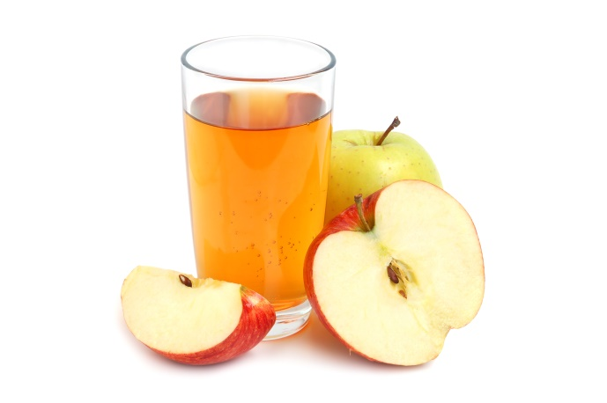
Part A: Potentiometric titration of malic acid
In apple juice, organic acids are mainly represented by malic (2-hydroxybutanedioic) acid. You will determine the concentration of malic acid by potentiometric titration.
- Add a 10.0 mL aliquot of apple juice and 50 mL of distilled H₂O to a 250 mL plastic beaker.
- Perform potentiometric titration of the resulting mixture with 0.1000 M NaOH solution using a pH meter by adding 0.5 mL portions of NaOH until pH reaches 11.
- Record your measurements in the following table:
V_{NaOH} | 0.0 | 0.5 | 1.0 | 1.5 | 2.0 | 2.5 | 3.0 | 3.5 | 4.0 | 4.5
pH
V_{NaOH} | 5.0 | 5.5 | 6.0 | 6.5 | 7.0 | 7.5 | 8.0 | 8.5 | 9.0 | 9.5
pH
Q1. Determine the range of NaOH volume (mL) corresponding to the equivalence point. Hint: It is the range with the greatest change in pH. Tick the correct box:
V_{NaOH} | 0.0 | □ | 0.5 | □ | 1.0 | □ | 1.5 | □ | 2.0 | □ | 2.5 | □ | 3.0
V_{NaOH} | 3.0 | □ | 3.5 | □ | 4.0 | □ | 4.5 | □ | 5.0 | □ | 5.5 | □ | 6.0
V_{NaOH} | 6.0 | □ | 6.5 | □ | 7.0 | □ | 7.5 | □ | 8.0 | □ | 8.5 | □ | 9.0
- For a more precise titration, repeat the potentiometry for the range from Q1 by adding 0.1 mL portions of 0.1000 M NaOH solution.

- Record your measurements in the following table:
V_{NaOH}
pH
Q2. Determine the more accurate range of NaOH volume (mL) corresponding to the equivalence point. Hint: It is the range with the greatest change in pH.
Q3. Write the reaction equation for the titration of the apple juice with NaOH. Assume that malic acid is the only acid in the apple juice.
Q4. Calculate the concentration (mg·mL⁻¹) of malic acid in the apple juice sample.
Part B: Standardisation of Cu(II) solution
You will determine the amount of reducing sugars in apple juice by Fehling’s method using Cu(II). To do this, you must first standardise the Cu(II) solution iodometrically.
- Transfer a 10.0 mL aliquot of Cu(II) solution to a 100.0 mL volumetric flask and dilute to the mark with distilled water (Solution 1).
- Transfer a 10.0 mL aliquot of Solution 1 to a conical flask. Add 5 mL of 1 M H₂SO₄ and 10 mL of 20% KI. Cover the flask and leave it for about 15 minutes in a dark place.
- Titrate the formed iodine with a standard solution of Na₂S₂O₃ until the colour turns pale yellow. Then add 2–3 drops of starch solution, continue titration until the blue colour of the titrated solution disappears.
- Repeat steps 2 and 3 as necessary.
Q5. Write the equations of the reactions that occurred during the standardisation of Cu(II).
Q6. Calculate the concentration (M) of Cu(II) in the initial solution.
Part C: Titration of reducing sugars
Note: Perform steps 1–2 in a fume hood.
- Add 10.0 mL of Cu(II) solution to an Erlenmeyer flask, and 10 mL of alkaline tartrate solution. Put 5–10 glass boiling stones (chips) in the flask. Heat the mixture to boiling. Add 2–3 drops of methylene blue indicator.
- Take the Erlenmeyer flask from the heater to the table and immediately titrate the boiling solution with apple juice until the blue colour of the solution fully disappears against the background of a brick-red precipitate.
- Repeat steps 1 and 2 as necessary.
Q7. Write the reaction equation for the titration with Cu(II) in alkaline media, assuming that glucose is the only reducing sugar in apple juice. Use the molecular formula of glucose.
Q8. Calculate the concentration (mg·mL⁻¹) of glucose in the apple juice.

Problem 34. Cottonseed oil
Equipment
Item | Quantity
Analytical balance (to 4 significant figures) | 1
Burette, 25 mL | 2
Stand with burette clamp | 1
Erlenmeyer flask, 250 mL with glass stopper | 2
Brown glass bottle, 50 mL | 1
Volumetric pipette, 10.0 mL | 1
Volumetric pipette, 25.0 mL | 1
3-valve pipette bulb | 1
Measuring cylinder, 10 mL | 1
Measuring cylinder, 25 mL | 1
Measuring cylinder, 100 mL | 1
Erlenmeyer flask, 250 mL | 2
Water bath | 1
Reflux condenser | 2
Boiling stones | 20–40
Funnel | 2
Pasteur pipette | 3
Finger adapters for handling hot glassware | 1 pair
Spatula | 2
Container for liquid waste, 1 L | 1
Chemicals
Name | State | Concentration | Quantity | Placed in | Label
Distilled water | Liquid | – | 500 mL | Wash bottle, 500 mL | H₂O dist.
Cottonseed oil | Liquid | to be determined | 10 mL | Glass bottle with a screw cap, 50 mL | Cottonseed oil
Sodium thiosulfate | Aqueous solution | 0.1000 M | 200 mL | Glass bottle with a screw cap, 250 mL | Na₂S₂O₃,  0.1000 M
Iodine trichloride | Solid | – | 0.45 g | Brown glass vial with a screw cap, 1.5 mL | ICl₃
Iodine | Solid | – | 0.50 g | Brown glass vial with a screw cap, 1.5 mL | I₂
Glacial acetic acid | Liquid | – | 50 mL | Brown glass bottle with a ground stopper, 100 mL | CH₃COOH glacial
Dichloromethane | Liquid | – | 50 mL | Glass bottle with a ground stopper, 100 mL | CH₂Cl₂
Potassium iodide | Aqueous solution | 20% | 100 mL | Glass bottle with a screw cap, 250 mL | KI, 20%
Hydrochloric acid | Aqueous solution | 0.5000 M | 100 mL | Glass bottle with a screw cap, 250 mL | HCl,  0.5000 M
Potassium hydroxide | Freshly prepared ethanolic solution | ~0.5 M | 100 mL | Glass bottle with a screw cap, 250 mL | KOH/  C₂H₅OH,  0.5 M
Starch | Aqueous solution | 1% | 4 mL | Eppendorf tube, 5 mL | Starch, 1%
Alkali Blue 6B | Ethanolic solution | 0.75% | 4 mL | Eppendorf tube, 5 mL | Alkali Blue, 0.75%
GHS Codes
Name | GHS Code(s)
Cottonseed oil | no hazards
Sodium thiosulfate | no hazards
Iodine trichloride | H272, H314
Iodine | H312, H332, H400
Glacial acetic acid | H226, H314
Dichloromethane | H351
Potassium iodide | H302, H315, H317, H319, H334, H372, H373, H411
Hydrochloric acid | H314, H331
Potassium hydroxide | H302, H314
Starch | no hazards
Alkali Blue 6B | H315, H319, H335

Cotton is one of Uzbekistan’s most important agricultural products and has long been known as the country’s “white gold”. It plays a major role in the national economy, providing export revenue and employment, though recent reforms have aimed to improve labour conditions and reduce reliance on forced labour in its production.
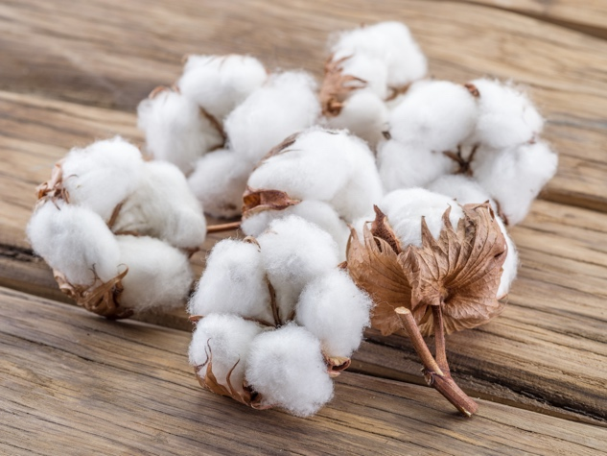
Cottonseed oil, which is extracted from the seeds of the cotton plant, is tested using key parameters such as saponification value and iodine value to determine its overall quality.
Part A: Determination of the saponification value
In this part, you will identify the saponification value of cottonseed oil volumetrically. The saponification value is the number of mg of KOH required to hydrolyse 1 g of a fat or oil.
Testing the sample:
- Fill the burette with 0.5000 M HCl solution.
- Weigh approximately 2.0 g of cottonseed oil in the Erlenmeyer flask. Record the weight.
- To the flask with the cottonseed oil sample, add 25.0 mL of ~0.5 M KOH/C₂H₅OH solution. Put 5–10 boiling stones (chips) in the reaction flask.
- Attach the reflux condenser with floating water onto the reaction flask.
- Reflux the content by intensive boiling of the water bath until all the oil disappears. Note: This step usually takes ca. 60 minutes.
- Disconnect the reflux condenser and remove the flask from the water bath.
- Add 0.25 mL Alkali Blue solution to the hot flask.
- Titrate the hot solution with 0.5000 M HCl until the red solution becomes blue. Record your answer.
Reference experiment:
- Skip step 2 and repeat steps 1, 3–8 from the above procedure without cottonseed oil. Record your answer.

Q1. Write the reaction equations for the saponification of triglyceride and neutralisation of KOH during the titration. Use the following simplified structure for triglyceride:
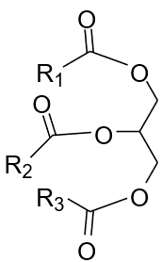
Q2. Determine the exact concentration (M) of the alcoholic KOH solution.
Q3. Calculate the saponification value (mg·g⁻¹) of the sample.
Part B: Determination of the iodine value
In this part, you will determine the iodine value of cottonseed oil through the volumetric method. Iodine value is a measure of the total number of double bonds present in fats and oils. It is expressed as the number of grams of iodine that will react with the double bonds in 100 grams of fats or oils. Firstly, you need to prepare the Wijs solution and then use it to determine the iodine value of cottonseed oil.
Note: Perform steps 1–9 in the fume hood.
- Weigh and dissolve 0.45 g of ICl₃ in 50 mL glacial CH₃COOH in a brown glass bottle with a ground stopper.
- Add 0.50 g I₂ to the ICl₃ solution in glacial acetic acid. Mix the contents of the bottle thoroughly until I₂ is completely dissolved. The resulting solution predominantly contains interhalogen X and is called Wijs solution.
Testing the sample:
- Fill the burette with Na₂S₂O₃ solution.
- Weigh approximately 0.1 g of cottonseed oil in the iodine flask. Record the mass.
- To the iodine flask with the cottonseed oil sample, add 10 mL of CH₂Cl₂, followed by 10.0 mL of Wijs solution.
- Immediately close the flask with a stopper soaked in KI solution and keep it in a dark place for 60 minutes.
- After 60 minutes, add 15 mL of 20% KI solution and 100 mL of distilled H₂O into the flask.
- Titrate the mixture with Na₂S₂O₃ solution until it turns pale yellow, then add
2–3 drops of starch solution and continue titrating until the dark blue colour of the solution disappears. Record your answer.
Reference experiment:
- Skip step 4 and repeat steps 3, 5–8 from the above procedure without cottonseed oil. Record your answer.
Q4. Determine the interhalogen X.
Q5. Write equations of the reactions occurring during the determination of the iodine number of cottonseed oil. Use the following simplified structure for unsaturated fatty acid residues:
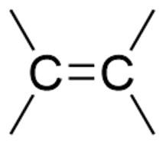
Q6. Determine the concentration (M) of X in the Wijs solution.
Q7. Calculate the iodine value (g·(100 g)⁻¹) of the sample.
The following table shows the saponification and iodine values of different oils:
Oil | Saponification value / mg·g⁻¹ | Iodine value / g·(100 g)⁻¹
Sunflower | 188–194 | 118–145
Fish | 180–192 | 142–176
Palm | 190–209 | 50–55
Butter | 210–232 | 26–40
Q8. Identify the oil from the table above that contains the highest number of:
- short-chain fatty acids;
- unsaturated fatty acids.

Problem 35. An unknown salt
Equipment
Item | Quantity
Analytical balance (to 4 significant figures) | 1
Spatula | 1
Beaker, 250 mL | 1
Funnel | 3
Volumetric flask, 250 mL | 1
Microplate (transparent 96-well plate) | 1
Micropipette 10–100 μL | 1
Micropipette tips | 6
Rack for micropipette tips | 1
Plastic beakers, 250 mL | 2
Volumetric pipette, 50 mL | 1
3-valve pipette bulb | 1
Glass rod | 1
Burette, 25 mL | 1
Stand with burette clamp | 1
Calibrated pH meter | 1
Container for liquid waste, 1 L | 1
Chemicals
Name | State | Concentration | Quantity | Placed in | Label
Distilled water | Liquid | – | 500 mL | Wash bottle, 500 mL | H₂O
Unknown salt | Solid | – | 1 g | Vial, 5 mL | Salt X
Barium chloride | Aqueous solution | 5% | 1 mL | Eppendorf tube, 2 mL | BaCl₂, 5%
Silver nitrate | Aqueous solution | 5% | 1 mL | Eppendorf tube, 2 mL | AgNO₃, 5%
Sodium nitrite | Aqueous solution | 5% | 1 mL | Eppendorf tube, 2 mL | NaNO₂, 5%
Hydrochloric acid | Aqueous solution | 5% | 1 mL | Eppendorf tube, 2 mL | HCl, 5%
Ammonia solution | Aqueous solution | 10% | 1 mL | Eppendorf tube, 2 mL | NH₃, 10%
Sodium hydroxide | Aqueous solution | 0.2000 M | 200 mL | Glass bottle with a screw cap, 250 mL | NaOH, 0.2000 M

GHS Codes
Chemical | GHS Code(s)
Unknown salt | H315, H319, H335
Barium chloride | H301, H332
Silver nitrate | H272, H314, H400, H410
Sodium nitrite | H272, H301, H400
Hydrochloric acid | H314, H331
Ammonia solution | H221, H314, H331, H400
Sodium hydroxide | H314

A very famous story of Khodja Nasreddin is about his encounter with Salt X. One sunny day in old Samarkand, Nasreddin met his neighbour:
“Do you know, dear neighbour, that this Salt X that I bought from Samarkand makes a loud noise when I throw it outside the window?”
“Impossible, respected Khodja, that is impossible! It’s only a very small amount!”
“Yes, but if I put it on the vial on the back of my donkey and throw it outside the window, it definitely makes a lot of noise!” the respected Nasreddin replied.
You are given a salt of an unknown canonical amino acid with the following molecular formula:
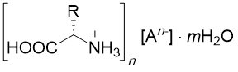
m is a non-zero integer number, whereas the anion A^{n−} can be any of the following anions: Cl⁻, Br⁻, I⁻, NO₃⁻, SO₄²⁻.
Note: The list of 20 canonical amino acids with their molecular formulae, molecular weight and pK_{a} values is given at the end of the problem.
- Weigh ca. 1 g of Salt X. Write down the exact mass that you will use for further calculations.
- Dissolve Salt X in 50 mL of distilled water in a beaker.
- Transfer the solution of Salt X quantitatively to a 250 mL volumetric flask.
- Fill the flask with distilled water up to the mark to obtain solution 1.
Part A: Qualitative analysis
In this part of the problem, you need to determine the anion A^{n−} by using qualitative reactions in a 96-well plate. You are provided with the following reagents: BaCl₂, AgNO₃, NaNO₂, HCl, NH₃.
Q1. Fill in the table below with the observations you would expect for each reaction pair. Indicate all colour changes and if any precipitate or gas is formed.
 | BaCl₂ | AgNO₃ | NaNO₂ + HCl
Cl⁻
Br⁻
I⁻
NO₃⁻
SO₄²⁻
Q2. Write the corresponding ionic reaction equations.
The solubility of silver halides AgHal (Hal = Cl⁻, Br⁻, I⁻) in an aqueous ammonia solution depends, in addition to other factors, on the solubility product (K_{sp}) of AgHal in water and the stability constant β of [Ag(NH₃)₂]⁺:
K_{sp}(AgCl) | K_{sp}(AgBr) | K_{sp}(AgI) | β(Ag(NH₃)₂⁺)
1.77 × 10⁻¹⁰ | 5.35 × 10⁻¹³ | 8.52 × 10⁻¹⁷ | 2.5 × 10⁷
Q3. Calculate the solubility (M) of AgHal for each halogen anion (Cl⁻, Br⁻, I⁻) in 1.00 L of 10% NH₃ solution (ρ = 0.958 g·cm⁻³). Note: Assume that the activity of the species equals its concentration.
Q4. Mix solution 1 with the provided reagents in the microplate according to the table below. If AgHal precipitate forms in reaction 2, add 70 µL of NH₃ to the reaction mixture. Record your observations.
Reaction number | Reaction mixture | Precipitate formed | Colour of the precipitate | Solubility of the precipitate in NH₃ | Colour of the resulting solution
1 | 70 μL solution 1  + 70 μL BaCl₂ | □ □  Yes No |  | -
2 | 70 μL solution 1  + 70 μL AgNO₃ | □ □  Yes No |  | □ □  Yes No
3 | 70 μL solution 1  + 70 μL HCl  + 70 μL NaNO₂ | – | – | –
Q5. Determine the anion A^{n−}. Assume that out of AgHal, only AgCl dissolves in ammonia solution at the given conditions.
Part B: Quantitative analysis
In this part of the problem, you need to determine the number of acidic protons and the molecular mass of Salt X by potentiometric titration.
- Transfer 50.0 mL of solution 1 into a 250 mL plastic beaker using a volumetric pipette.
- Perform potentiometric titration of the resulting mixture with 0.2000 M NaOH solution using a pH meter by adding 0.5 mL portions of NaOH until pH reaches 11.

- Record your measurements in the following table:
V_{NaOH} | 0.0 | 0.5 | 1.0 | 1.5 | 2.0 | 2.5 | 3.0 | 3.5 | 4.0 | 4.5
pH
V_{NaOH} | 5.0 | 5.5 | 6.0 | 6.5 | 7.0 | 7.5 | 8.0 | 8.5 | 9.0 | 9.5
pH
V_{NaOH} | 10.0 | 10.5 | 11.0 | 11.5 | 12.0 | 12.5 | 13.0 | 13.5 | 14.0 | 14.5
pH
V_{NaOH} | 15.0 | 15.5 | 16.0 | 16.5 | 17.0 | 17.5 | 18.0 | 18.5 | 19.0 | 19.5
pH
Q6. Determine the range(s) of NaOH volume (mL) corresponding to the equivalence point(s). Hint: These are the ranges with the greatest change in pH. Tick the correct box(es):
V_{NaOH} | 0.0 | □ | 0.5 | □ | 1.0 | □ | 1.5 | □ | 2.0 | □ | 2.5 | □ | 3.0
V_{NaOH} | 3.0 | □ | 3.5 | □ | 4.0 | □ | 4.5 | □ | 5.0 | □ | 5.5 | □ | 6.0
V_{NaOH} | 6.0 | □ | 6.5 | □ | 7.0 | □ | 7.5 | □ | 8.0 | □ | 8.5 | □ | 9.0
V_{NaOH} | 9.0 | □ | 9.5 | □ | 10.0 | □ | 10.5 | □ | 11.0 | □ | 11.5 | □ | 12.0
V_{NaOH} | 12.0 | □ | 12.5 | □ | 13.0 | □ | 13.5 | □ | 14.0 | □ | 14.5 | □ | 15.0
V_{NaOH} | 15.0 | □ | 15.5 | □ | 16.0 | □ | 16.5 | □ | 17.0 | □ | 17.5 | □ | 18.0
- For a more precise titration, repeat the potentiometry for the range from Q6 by adding 0.1 mL portions of 0.2000 M NaOH solution. Hint: If you found two or more equivalence points, choose the one with the greatest change in pH.
- Record your measurements in the following table:
V_{NaOH}
pH
Q7. Determine the more accurate range of NaOH volume (mL) corresponding to the equivalence point(s). Hint: It is the range with the greatest change in pH.
Q8. Determine the number of acidic protons in Salt X.
Q9. Calculate the molecular mass (M) of Salt X.
Q10. Determine the molecular formula of Salt X.
Table. 20 canonical amino acids
Name | Molecular  Weight | Molecular  Formula | pK_{a}(-COOH) | pK_{a}(-NH₃⁺) | pK_{a}(-R)
Alanine | 89.10 | C₃H₇NO₂ | 2.34 | 9.69 | –
Arginine | 174.20 | C₆H₁₄N₄O₂ | 2.17 | 9.04 | 12.48
Asparagine | 132.12 | C₄H₈N₂O₃ | 2.02 | 8.80 | –
Aspartic acid | 133.11 | C₄H₇NO₄ | 1.88 | 9.60 | 3.65
Cysteine | 121.16 | C₃H₇NO₂S | 1.96 | 10.28 | 8.18
Glutamic acid | 147.13 | C₅H₉NO₄ | 2.19 | 9.67 | 4.25
Glutamine | 146.15 | C₅H₁₀N₂O₃ | 2.17 | 9.13 | –
Glycine | 75.07 | C₂H₅NO₂ | 2.34 | 9.60 | –
Histidine | 155.16 | C₆H₉N₃O₂ | 1.82 | 9.17 | 6.00
Isoleucine | 131.18 | C₆H₁₃NO₂ | 2.36 | 9.60 | –
Leucine | 131.18 | C₆H₁₃NO₂ | 2.36 | 9.60 | –
Lysine | 146.19 | C₆H₁₄N₂O₂ | 2.18 | 8.95 | 10.53
Methionine | 149.21 | C₅H₁₁NO₂S | 2.28 | 9.21 | –
Phenylalanine | 165.19 | C₉H₁₁NO₂ | 1.83 | 9.13 | –
Proline | 115.13 | C₅H₉NO₂ | 1.99 | 10.60 | –
Serine | 105.09 | C₃H₇NO₃ | 2.21 | 9.15 | –
Threonine | 119.12 | C₄H₉NO₃ | 2.09 | 9.10 | –
Tryptophan | 204.23 | C₁₁H₁₂N₂O₂ | 2.83 | 9.39 | –
Tyrosine | 181.19 | C₉H₁₁NO₃ | 2.20 | 9.11 | 10.07
Valine | 117.15 | C₅H₁₁NO₂ | 2.32 | 9.62 | –

Problem 36. Khodja Nasreddin’s secret message
Equipment
Item | Quantity
Microplate with 96 wells (transparent) | 1
Micropipette, 10–100 μL | 1
Tips for the micropipette of the appropriate size | 11
Rack for micropipette tips | 1
Rack for Eppendorf tubes | 1
Container for liquid waste, 1 L | 1
Chemicals
Name | State | Concentration | Quantity | Placed in | Label
Distilled water | Liquid | – | 500 mL | Wash bottle,  500 mL | H₂O dist.
Methyl orange | Aqueous solution | 0.1% | 5 mL | Centrifuge tube, 15 mL | MO, 0.1%
Hydrochloric acid | Aqueous solution | 0.0500 M | 15 mL | Centrifuge tube, 15 mL | HCl, 0.05 M
Sodium hydroxide | Aqueous solution | 0.0500 M | 15 mL | Centrifuge tube, 15 mL | NaOH, 0.05 M
HCl solutions  I–III | Aqueous solutions | To be determined | 5 mL | Centrifuge tube, 15 mL | I–VIII
NaOH solutions  IV–VIII | Aqueous solutions | To be determined | 5 mL | Centrifuge tube, 15 mL | I–VIII
GHS Codes
Chemical | GHS Code(s)
Methyl orange | H301
Hydrochloric acid | H314, H331
Sodium hydroxide | H314

Closer to the end of this Preparatory Problems set, Khodja Nasreddin wants to inform you about an important event happening this year. Khodja Nasreddin loves chemistry and he is very good at hiding secrets. Thus, he encrypted the information in solutions I–VIII. The solutions I–III contain HCl and the solutions IV–VIII contain NaOH in different concentrations. Khodja Nasreddin believes that the talented chemists around the world can read his message.
To decipher the information, he proposes the following experiment:
- Fill all the wells of the microplate with 10 μL of methyl orange (MO) solution.
- Add 100 μL of solution I to the A1 well. Then add 20 μL of 0.05 M NaOH solution. Record the colour of the obtained solution.
- Add 100 μL of solution I to the B1 well. Then add 40 μL of 0.05 M NaOH solution. Record the colour of the solution.
- Continue the procedure as described in steps 2 and 3 by keeping the volume of solution I constant. Increase the volume of the 0.05 M NaOH by 20 μL in each new well until the colour of the solution changes.
- Once you observe the colour change, repeat the addition as in steps 2 and 3 with the next solution.
Note: Each new solution is added to the wells column-wise (A1–H1, A2–H2, …., A12–H12).
- Continue the addition of the solutions until the 96-well plate is filled. The order of adding the solutions is given in Table 1.
We strongly recommend:
- Follow the instructions and follow the specific order given in the task.
- Solutions I–III are to be basified with 0.05 M NaOH solution, while solutions
IV–VIII are to be acidified with 0.05 M HCl solution.
- Keep a specific tip for a specific solution.
- See Figures 1–6 on the next pages for visual guidance on performing the experiment.
Table 1. Order of addition of the solutions
Order of addition | Solution | Order of addition | Solution | Order of addition | Solution
1 | I | 10 | VIII | 19 | VIII
2 | IV | 11 | I | 20 | II
3 | II | 12 | IV | 21 | IV
4 | VII | 13 | III | 22 | I
5 | I | 14 | IV | 23 | III
6 | VI | 15 | VII | 24 | VI
7 | IV | 16 | II | 25 | II
8 | V | 17 | IV | 26 | IV
9 | III | 18 | II | 27 | II

As can be seen from Table 1, some solutions will need to be added multiple times. Continuing to “titrate” according to the order in Table 1 and Figures 1–6, you should reach the well H12 and complete the “titration” with solution II.
Hint: In this task, “titrate” means “acidify” or “basify”, depending on which solution is added.
Q1. Decipher Khodja Nasreddin’s cryptogram.
Q2. Determine the concentration ranges of solutions I–VIII.
Q3. Give the number(s) of solution(s) (out of I–VIII) that can be used to replace solution II at the end of the sequence, so that the cryptogram pattern remains unchanged.
For arbitrary concentrations of “titrated” solutions, the working scheme is as follows:
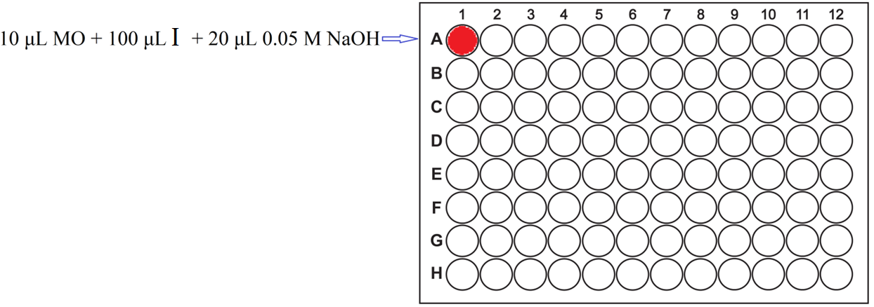
Figure 1. Step 1 – 100 µL of solution I is basified with 20 µL of NaOH.

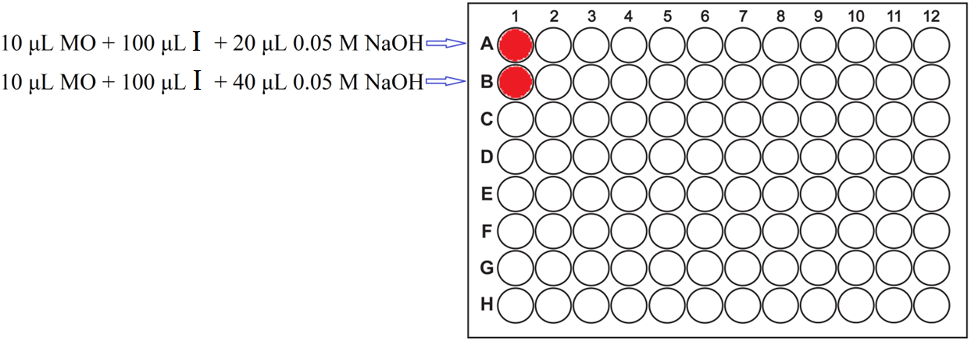
Figure 2. Step 2 – 100 µL of solution I is basified with 40 µL of NaOH.
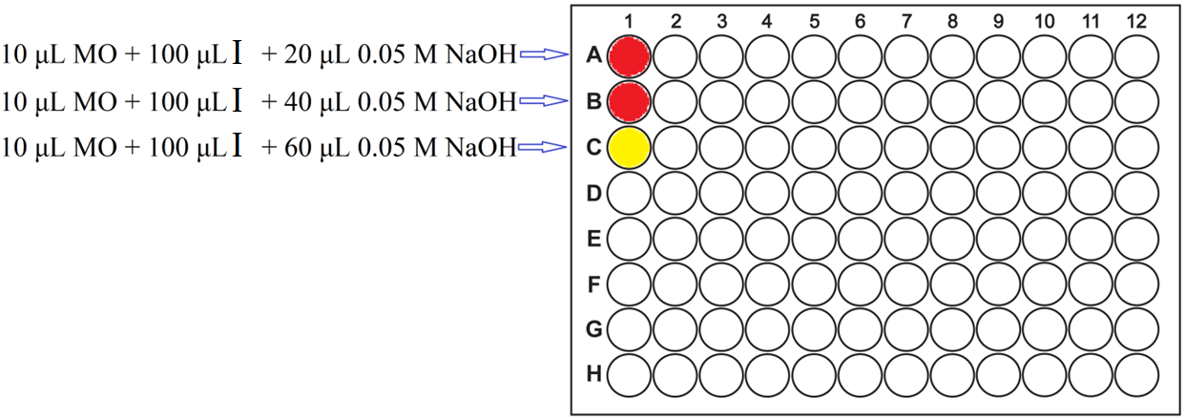
Figure 3. Step 3 – 100 µL of solution I is basified with 60 µL of NaOH. A colour change is recorded, which indicates the end of the “titration” of solution I.

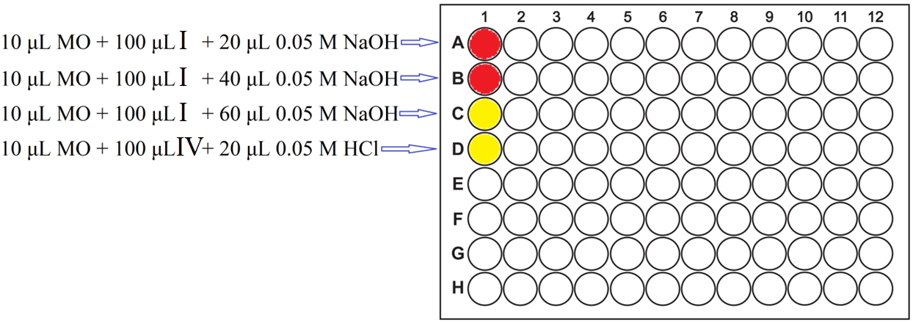
Figure 4. Step 4 – 100 µL of solution IV is acidified with 20 µL of HCl.

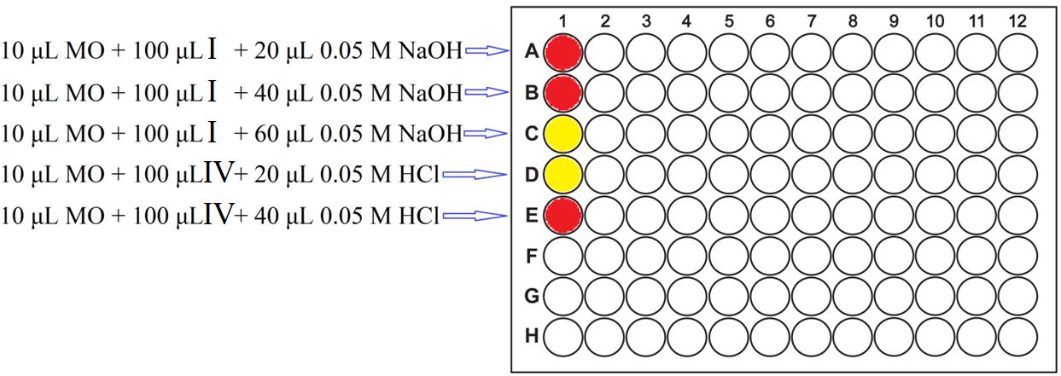
Figure 5. Step 5 – 100 µL of solution IV is acidified with 40 µL of HCl. A colour change is recorded, which indicates the end of the “titration” of solution IV.
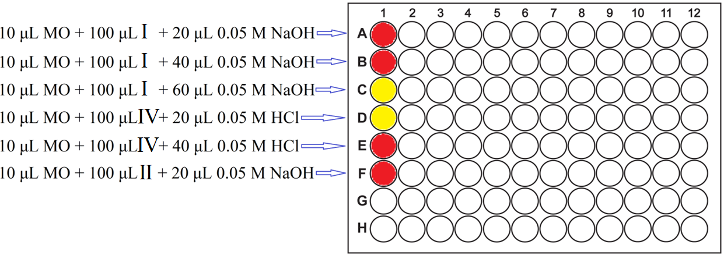
Figure 6. Step 6 – 100 µL of solution II is basified with 20 µL of NaOH.

